004 TypeScript – arrays

TypeScript Kata List – Blog Page

TypeScript Kata List – Github Page

# Duration

10 Minutes

# Brief

Using arrays

### For More Information

BING/GOOGLE: “TypeScript arrays”

# Instructions

Get tutorial folder or the entire katas-typescript repo.

Open the [before/*.sln] file and execute the kata.

Feel free to execute this kata multiple times because repetition creates motor memory.

# Github

* Before (start kata with this)
  + [https://github.com/](https://github.com/robertdunaway/katas-typescript/tree/master/001%20TypeScript%20-%20declare%20variables)
* After
  + [https://github.com/](https://github.com/robertdunaway/katas-typescript/tree/master/001%20TypeScript%20-%20declare%20variables/after)

# Kata

Create an array named “list1” with the values 1, 2, 3. Send result to the console.

[highlight below for one possible answer]

// New array

var list1: number[] = [1, 2, 3];

console.log('list1 array = ' + list1);

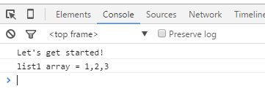

Create an array named “list2” with values 1,2,3. This time use a generic array. Send result to the console.

[highlight below for one possible answer]

// results in the same array as the one above. This is a style preference.

var list2: Array<number> = [1, 2, 3];

console.log('list2 array = ' + list2);

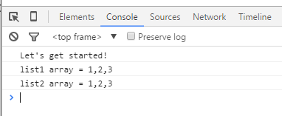

Create an array named “anyList” with values 1,true,”three”. This time use type any to create the array. Send result to the console.

[highlight below for one possible answer]

//Creating an array of type “**any”**.

var anyList: any[] = [1, true, "three"];

console.log('anyList[] = ' + anyList);

anyList[1] = 100;

console.log('anyList[] = ' + anyList);

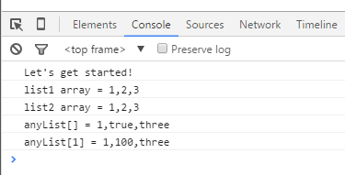

Create an array named “list3” of type “string” and set its length to 10. Send result to the console.

[highlight below for one possible answer]

// Set the length of an array structure to 10.

var list3:string[] = new Array(10);

console.log('list3 = ' + list3);

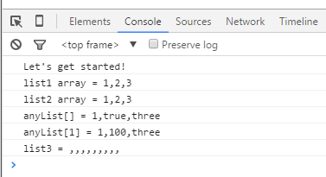

# Next

Take a few minutes and imagine more examples.